

**Lab Manual- Container sample: Build and Run a Dotnet web application with Azure Container Instance (ACI)**

**Prepared for**:

**Date:** 18th Dec 2023

**Prepared by:**

Document Name: Lab Manual **Document Number** AZLab992

**Contributor:**

Contents

1. Objective 3

2. Create a Simple .NET Core Web Application: 3

3. Create a Dockerfile: 4

4. Build the Docker Image: 5

5. Run the Docker Container: 6

6. Test the Application running in Docker Container: 6

7. Build Own Image for Docker Hub 7

8. Create Azure Container Instance 8

# Objective

Creating a Docker image for a simple .NET Core web application involves a few steps. Below is a basic example of creating a Docker image for a simple .NET Core web application, Publish on Docker hub and Pull this image in Azure Container Instance. Make sure you have Docker and .NET Core installed on your system.

# Create a Simple .NET Core Web Application:

* Run Following command to create webapp

Dotnet new webapp -o myWebApp –-no-https

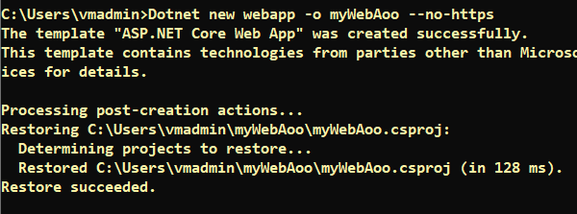

* Go Inside myWebApp directory

Cd myWebApp

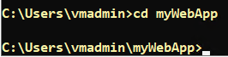

* Type Code . to open the project in VSCode

code .



* Make the changes in index.chtml under **Pages** Directory and **Save**

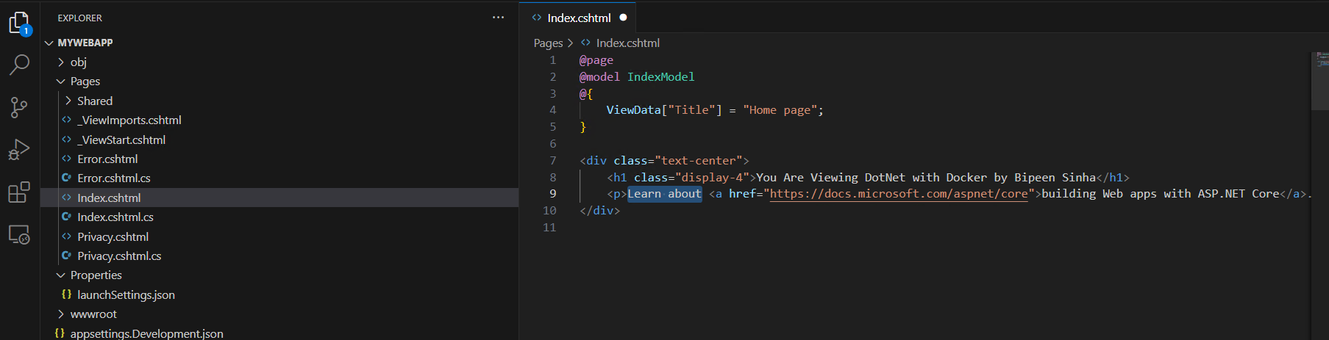

# Create a Dockerfile:

* Create a file named Dockerfile (without any file extension) in the same directory as your project. Add the following content to the Dockerfile:

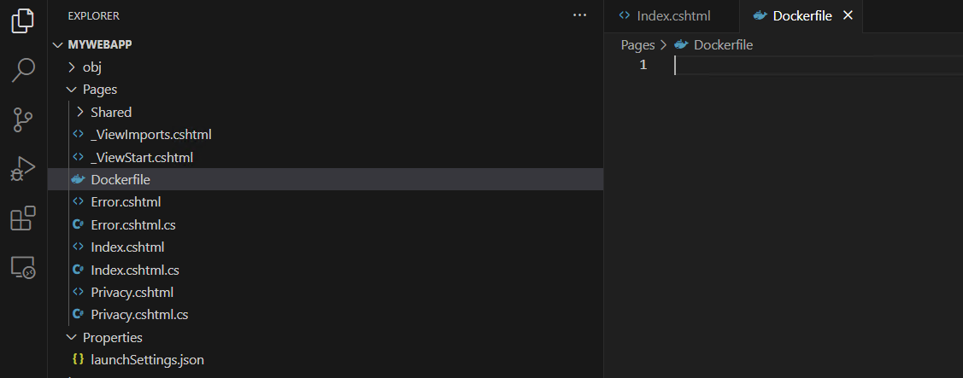

Type below lines in Dockerfile

FROM mcr.microsoft.com/dotnet/sdk:7.0 as build

WORKDIR /app

# Copy csproj and restore as distinct layers

COPY *.csproj ./

RUN dotnet restore

# Copy everything else and build

COPY . ./

RUN dotnet publish -c Release -o out

# Build runtime image

FROM mcr.microsoft.com/dotnet/aspnet:7.0 as base

WORKDIR /app

COPY --from=build /app/out .

ENTRYPOINT ["dotnet", "mywebapp.dll"]

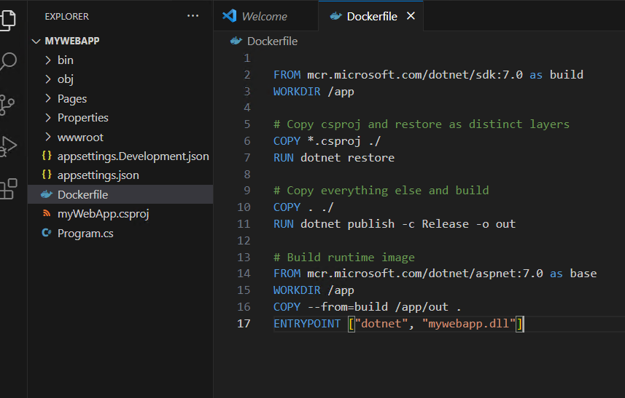

# Build the Docker Image:

* Open a terminal and navigate to the directory containing your Dockerfile. Run the following command to build the Docker image:

docker build -t mywebapp .

This command builds an image with the tag **mywebapp**.

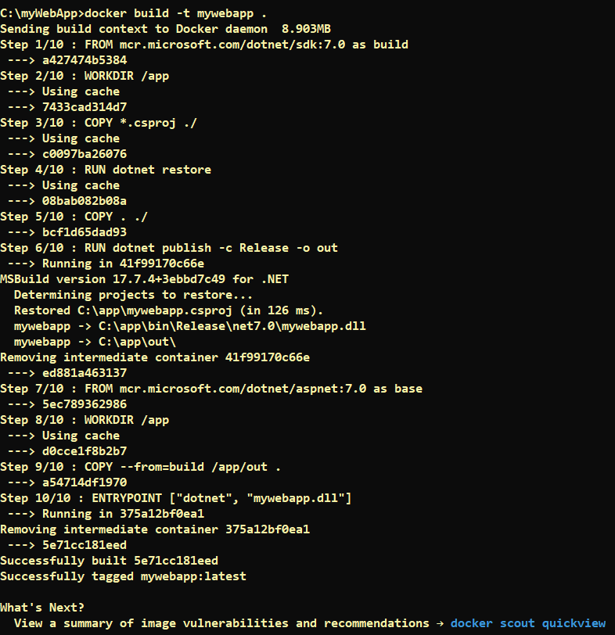



# Run the Docker Container:

Once the image is built, you can run a container based on that image:

docker run -it --rm -p 5000:80 --name demo mywebapp:latest

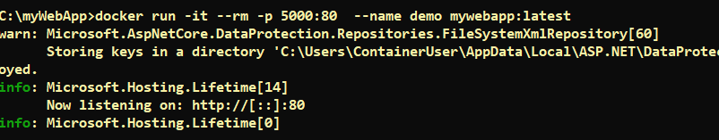

# Test the Application running in Docker Container:

Launch the webapp by typing below in browser

http://localhost:5000/

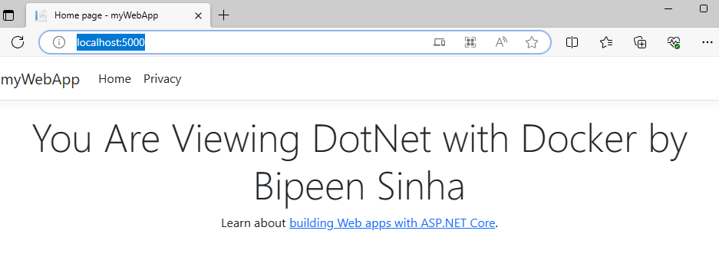

# Build Own Image for Docker Hub

docker build -t bipeen2001/devops:dotnet .

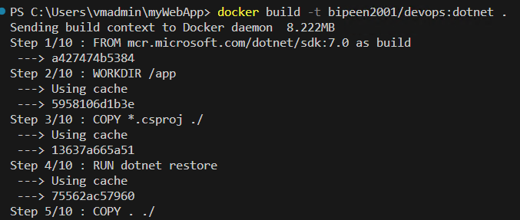

docker run -it --rm -p 5001:80 --name demo88 bipeen2001/devops:dotnet



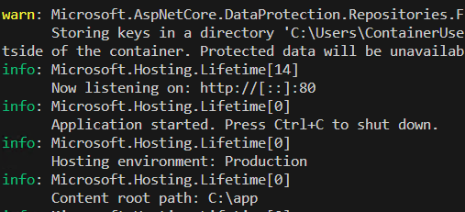

**http://localhost:5001/**

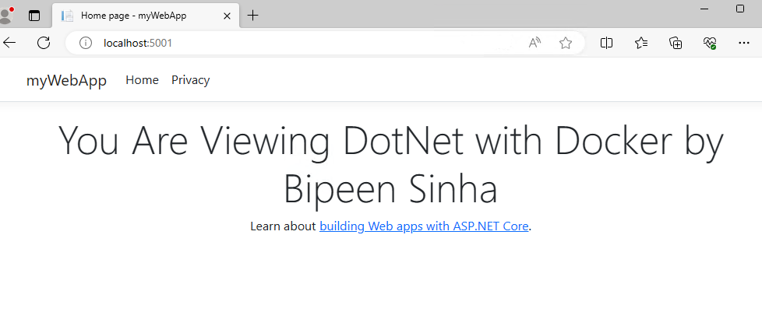

docker push bipeen2001/devops:dotnet

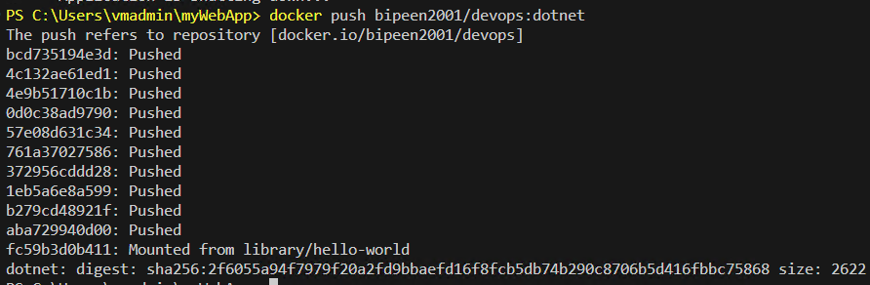

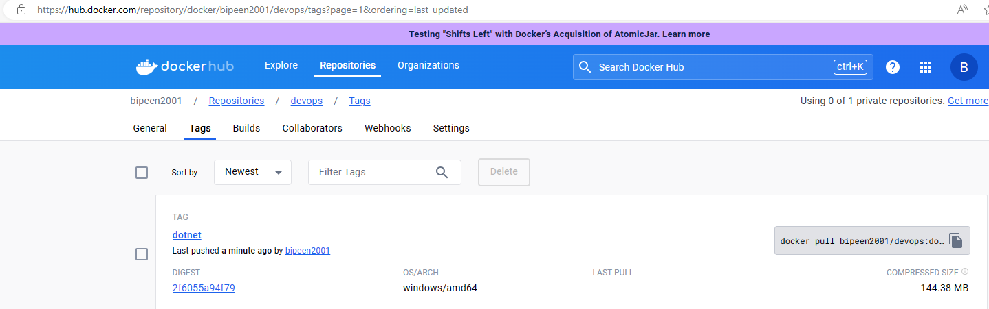

# Create Azure Container Instance

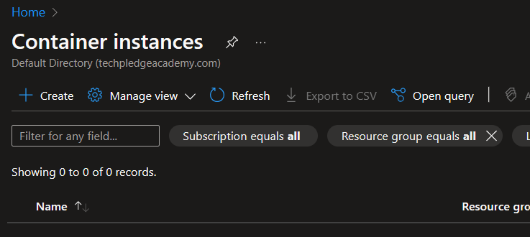

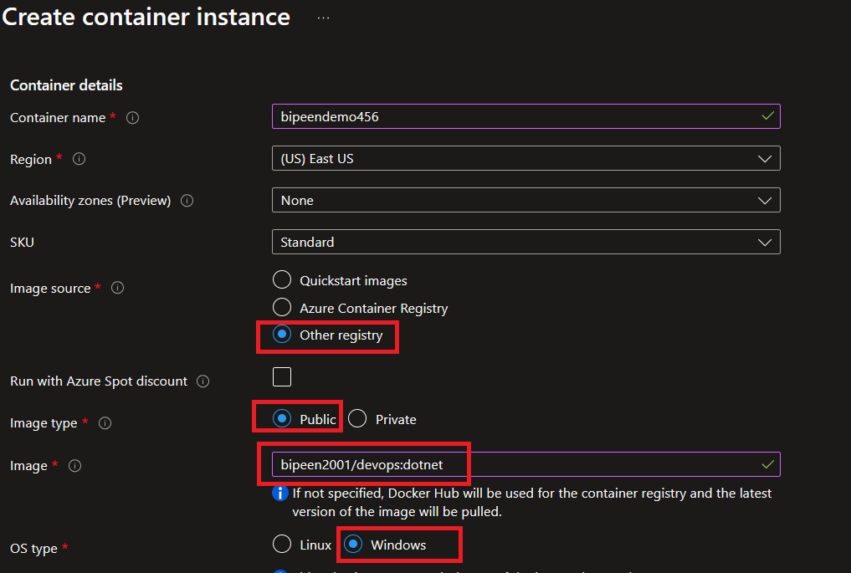

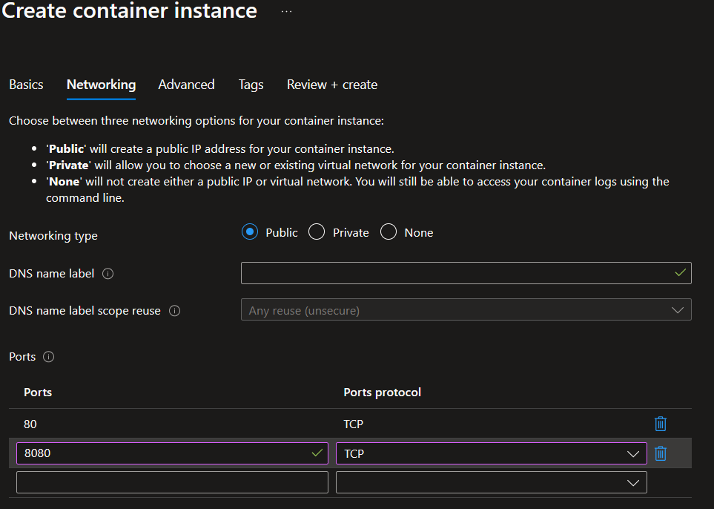

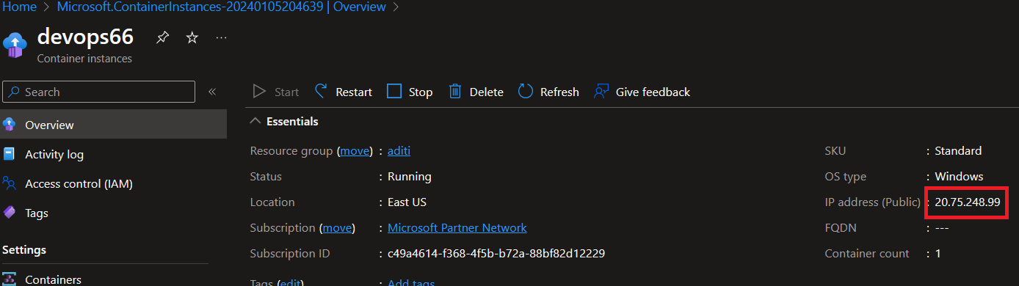

<http://20.75.248.99/>

